Docker & Kubernetes
Docker made containerization easy
It helps to build , ship & share

container can be launched - foreground (docker run nginx )– ctrl c, background
docker ps – status of container
docker ps -a – exited containers also

background mode
docker run -d httpd – preferred , container runs in an detached mode

docker ps – you see container running in detached id
container id , image , command – (docker-entrypoint) , created , status , ports , names

docker inspect nginx – for image information (it contains the command that run when an instance is created)
we can have our own names for the container
docker rm -f `docker ps -aq` - clear containers – remove containers

containers also have it owns ip addresses also
container cannot be accessed directly from outside world

docker run -d -p 1234:80 nginx (port mapping)
docker ps

docker run -d -P ngninx( capital P give random mapping)
1024 , we can give generall more than 1024

Docker stats –no-stream

Dynamic allocation of recourses (RAM/Memory/CPU) – in containerization using docker

Entering the docker
docker exec -it containerid bash
cd /usr/nginx/html# ls
apt get install vim
exit - ctrl+p+q – come back to the host machine

docker exec containerid hostname -i (running without entering the container)
docker logs containerid – dumps data
docker logs containerid -f : live logs
docker stop containerid (or id’s with space separated)
docker start containerid (start back the container)
restart the container – with docker random port – port changes

docker container prune – this will remove all stopped containers
docker rm -f `docker ps -aq` - removing all the containers

sudo su -
docker run -d -P nginx

103 docker ps
104 docker exec -it contid bash
apt-get update
apt-get install vim
cd /usr/share/nginx/html
vi index.html

i for inserting the file
escape :WQ
ctrl+pq

105 docker ps
106 docker exec 5ff1a30c6595 hostname -i
107 clear
108 docker ps
109 docker logs 5ff1a30c6595
110 clear
111 docker logs -f 5ff1a30c6595
112 clear
113 docker ps
114 docker stop 5ff1a30c6595 a4fc6d427e8e
115 docker start 5ff1a30c6595 a4fc6d427e8e
116 docker ps
117 docker restart ef0b64237a6a
118 docker rm ef0b64237a6a
119 docker rm -f ef0b64237a6a
120 clear
121 docker container prune
122 docker ps -aq
123 docker rm -f `docker ps -aq`

Ctrl + c – to come out of the logs

docker system df - docker system utilization

inside images – there are different layers
docker history imagegine – to see the layers
image is a set of readonly layers

image is like a disposable glass – we cannot edit , we need to create a new image
new version of image for new code
container life time is temporary – changes also deleted if deleted
we never change the container in general

Think Writable layer inside the container for editing (overly2)
App tomcat java
Image layers are not editable

Creating an image
Takes OS Image
Run it as a container
Make the change inside the container
Convert it to a new image

3 mode of running container – interactive terminal mode
docker run -it ubuntu:16.04 --- made you interact with the terminal

docker commit -m “nginx with ubuntu” containerid newimagename:v1
docker commit -m “naresh nginx” ‘CMD /usr/sbin/nginx -g “daemon off;”’ -c ‘EXPOSE 80’ containerid nareshnginx:v2 (setting up the start commands for the image)

docker pull ubuntu:16.04
docker run -it ubuntu:16.04

apt-get update
apt-get install -y vim nginx
cd /var/www/html/
vi index*

115 docker commit -m "naresh nginx" -c 'CMD /usr/sbin/nginx -g "daemon off;"' -c 'EXPOSE 80' f74b70798caf nareshnginx:v2
116 docker images
117 clear
118 docker run -d -P nareshnginx:v2 118 docker run -d -P nareshnginx:v2

vi pod.yml --- file
press i ---- insert content
esp:wq -- saving file
once change is done

esc
:wq
Enter

Ctrl+p+q to come out of the container

vi dockerfile

FROM ubuntu:16.04
RUN apt-get update
RUN apt-get install -y nginx vim
RUN rm /var/www/html*
RUN echo “this is automation” > /var/www/html/inxed.html
CMD /usr/sbin/nginx -g “daemon off;”
EXPOSE 80

docker build -t sainathauto:v1 .

FROM sainath:v1
RUN rm /var/www/html/*
COPY index.html /var/www/html/ - copying the file from the location

cd

git clone http://github.com/lerndevops/educka
cd educka/docker/images

141 ls -l
142 more dockerfile_myapp
143 cd ..
144 cd code/

146 ls -l
147 cd ../images/
148 docker build -t app:v1 -f dockerfile_myapp /root/educka/docker/code

WORKDIR myapp – setting up the working directory
ENTRYPOINT [“python”,”myapp.py”]

Environment variable we can set them in docker file
Docker run -d -p DBHOST=www.prodhost.com test

FROM ubuntu:bionic

ENV DBHOST www.devdb.com

RUN apt-get update && apt-get install -y curl
RUN apt-get update && apt-get install -y nginx

EXPOSE 80

CMD ["nginx", "-g", "daemon off;"]

HEALTHCHECK CMD curl localhost:80
rm dockerfile – deletes file
vi dockerfile – creates file

docker run test1 echo “Hello Team”
cmd will be overridden in this case

ENTRYPOINT[“/bin/ping”,”localhost”] – it will not be overridden – safe
ENTRYPOINT is best

ENTRYPOINT for specifying the command and CMD for specifying the variables
docker rmi http – deletes the images
docker image prune -a (removes all the unused images)

docker login

docker push sainathapp
docker tag test3 leaddevops/nareshapps:v1
docker push leaddevops/nareshapps:v1

docker rm -f `docker ps -aq` --- remove containers

Why Manager
To assign work
To get new projects
Leave management
Work management
Promotions
Adding more members

Container Orchestration
Maintain the desired state
Scalability
Share the load
Auto Healing
Auto Scaling
Zero downtime upgrades/rollbacks
Containers & NODEs communication
Storage management
Security – RBAC and Certificates (devSECops)

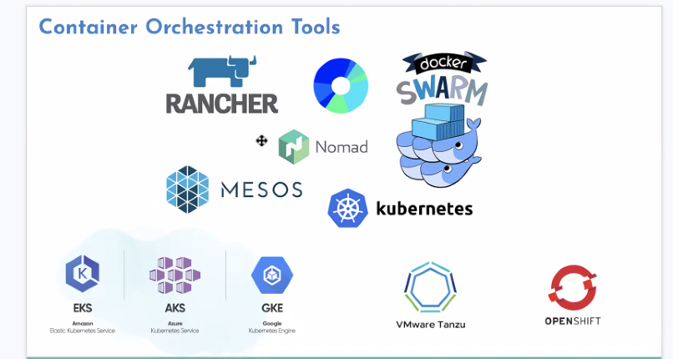

Kubernetes is a container orchestration tool

Kubernets supports , docker , contaierd , cri-o
Kubernets.io

Master – Nodes
We can have multiple masters also

KUBECTL – Client component

Master API-Server , Scheduler , Controller Manager , ETCD
API Server is the principle component of Kubernets (KUBECTL interacts with it)
Scheduler – tell API server which node is good to run the container
Controller Manager – to maintain the desired state (10 containers)
ETCD – key value pair database , how many nodes , how many containers

Node
KUBELET – interacts with API Server , slave to API server
Docker

Master can also have KUBELET & Docker , we don’t run containers but we need to install
Weave , Flannel are famous of network installation along with Kubernetes

Kubeadm - Components of kubenetes are installed as container only
Kubelet only runs as service not as a container

For quiting from ubunto – just click q
We run Pod in kubernets not containers
We wrap a container with a Pod
Pod maintain the states
Pod is the simplest object to use in Kubernetes

Kubenetes it is not suggested to go with imperative commands – one line commands
yml – is plain structured language
yml – keyvalue , array , dictionary
kuberbetes supports yml , json

kubectl create -f pod.yml
kubectl apply -f pod.yml – generally for update (it can also create if not there)

kubectl exec -it mypod -- bash (enter into pod)

vi pod.yml --- file
press i ---- insert content
esp:wq -- saving file
ctrl+p+q to exit the pod or conatiner
crl+c - to come out of running cmd
esp:q! – coming out of vi editor

kubectl delete pods --all – deletes all the pods
labels are assign to pods to quickly identify the pods
kubernetes we use labels everywhere

kubectl run pod1 --image nginx --labels=”env=prod,type=app”
kubectl run pod2 –image nginx --labels=”env=sit,type=app”
kubectl get pods -l type=prod
kubectl get pods --show-labels

we can generate the yml using kubectl

83 kubectl run pod2 --image nginx --labels='env=qawq,type=app' --dry-run=client -o yaml
kubectl run pod2 --image nginx --labels='env=qawq,type=app' --dry-run=client -o json
clear
kubectl get pods
kubectl get pods pod1
kubectl get pods pod1 -o yaml
kubectl get pods pod1 -o json

kubectl explan pod.spec
kubectl explain pod.metadata

https://github.com/lerndevops/educka

training material

A pod can contain another dependent helper container
kubectl delete all –all deleting pods

multi container pod
kubectl logs mypod -c xyz : logs from xyz container in multi container pod

multicontainer pods
staticpodpath : /etc/Kubernetes/manifests
testpod-node2 – static pod with node extension

16 cd /var/lib/kubelet/
17 ls -l
18 more config.yaml
19 cd /etc/kubernetes/manifests
20 clear
21 ls
22 vi ex.yml
23 docker ps |grep tester
24 ls
25 rm ex.yml
26 history

Kube-controler , kube-scheduler , kube-apiserver are static pods in master

Namespace
Grouping the pods using the namespace , so that all the commands are specific to namespace
Deleting namespaces will delete the pods associated with it

135 kubectl get pods
136 kubectl delete pods --all
137 kubectl create ns aparna
138 kubectl run a-pod --image nginx -n aparna
139 kubectl get pods
140 kubectl get pods -n aparna
141 kubectl get pods
142 kubectl get pods -n aparna
143 clear
144 kubectl get pods
145 kubectl get ns
146 kubectl get pods -n kube-system
147 kubectl delete ns Aparna

When you run the experimental containers we can limit the utilization
kubectl run pod1 --image nginx –limits=’cpu=0.5,memory=1200Mi’
we can give minimum and maximum limits of utilization

155 kubectl run pod1 --image nginx --limits='cpu=0.5,memory=1200Mi'
156 kubectl run pod2 --image nginx --requests='cpu=0.3,memory=500Mi' --limits='cpu=0.5,memory=1200Mi'
157 kubectl get pods -o wide
158 kubectl describe pod pod2

Kubectl explain pod.spec.containers -- for explaining the container

Liveness prob , checks the health of the Pod , example making a http get call or tcp port check

kubectl create -f https://raw.githubusercontent.com/lerndevops/educka/master/pods/probes/lp-nginx-pod.yml
kubectl get pods
kubectl describe pod lp-nginx-demo
clear
kubectl get pods
kubectl delete pod lp-nginx-demo

Liveness Probe – restart
Readiness Probe

Services

With the cluster you can access using the IP address of the pod
User Service (nodeport) Pod (pord port)

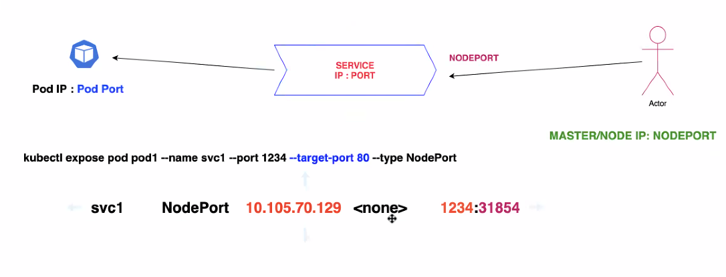

184 kubectl run pod1 --image nginx

189 kubectl get pods -o wide
190 curl 10.36.0.1:80
191 clear
192 kubectl get pods
193 kubectl expose pod pod1 --name svc1 --port 1234 --target-port 80 --type NodePort
194 kubectl get services

If we don’t mention type NodePort , it will be part of the cluster
Ex: database
Jdbc:odbc:SVC-name:svc-port/dbname

211 kubectl delete all --all

216 kubectl run pod1 --image nginx
217 kubectl expose pod pod1 --name svc1 --port 1234 --target-port 80
218 kubectl get pods
219 kubectl get svc
220 curl 10.108.239.65:1234
221 clear
222 kubectl get svc

Service has the capability of load balancing also
Selector under service describe the pod selection

Controller is to maintain the desired state
It has multiple components

RC,RS,Deployment,DaemonSet,Job,CronJob

Replication controller

228 kubectl delete svc,pods --all
229 clear
230 kubectl explain rc
231 clear
232 kubectl create -f https://raw.githubusercontent.com/lerndevops/educka/master/controllers/rc-ex1.yml
233 kubectl get rc
234 kubectl describe rc tomcatrc
235 kubectl get pods -o wide
236 clear
237 kubectl get pods -o wide
238 kubectl kubectl delete pod tomcatrc-2qrrq
239 kubectl delete pod tomcatrc-2qrrq
240 kubectl get pods -o wide
241 kubectl delete pods --all
242 kubectl get pods -o wide
243 clear
244 kubectl scale rc tomcatrc --replicas 6
245 kubectl get pods -o wide
246 kubectl scale rc tomcatrc --replicas 2
247 kubectl get pods -o wide
248 clear
249 kubectl delete rc tomcatrc
250 kubectl get pods -o wide
251 clear
252 kubectl run pod1 --image lerndevops/tomcat:8.5.47 --labels='app=tomcat'
253 kubectl create -f https://raw.githubusercontent.com/lerndevops/educka/master/controllers/rc-ex1.yml
254 kubectl get pods
255 kubectl describe rc tomcatrc
256 clear
257 kubectl run tester --image lerndevops/tomcat:8.5.47 --labels='app=tomcat'
258 kubectl get pods

RS Controller – similar to RC Controler
We can expose service for RS , service acts also as an load balancer

from NODE : while true;do curl svcIP:svcPORT;sleep 1;echo "";done

263 kubectl explain rs
264 clear
265 kubectl create -f https://raw.githubusercontent.com/lerndevops/educka/master/controllers/rs-ex1.yml
266 kubectl get rs,pods
267 kubectl delete pod test-k7lhx
268 kubectl get rs,pods
269 clear
270 kubectl expose rs test --port 1234 --target-port 3000 --type NodePort
271 kubectl get svc
272 kubectl get pods -o wide
273 cldar
274 clear
275 kubectl scale rs test --replicas 6
276 kubectl get pods -o wide
277 kubectl scale rs test --replicas 1
278 kubectl scale rs test --replicas 2
279 clear
280 kubectl describe svc test
281 kubectl get pods -l tier=frontend
282 kubectl delete all --all

RS can also have match expressions – RC don’t user match expressions

Deployment controller – it helps to perform rolling update – it is on top of RS controller

286 kubectl create deploy deploy1 --image nginx
287 kubectl get all
288 clear
289 kubectl describe deploy deploy1
290 clesar
291 clear
292 kubectl delete deploy deplo1
293 kubectl delete deploy deploy1
294 clear
295 kubectl explain deploy
296 kubectl explain deploy.spec
297 kubectl explain deploy.spec.strategy
298 kubectl explain deploy.spec.strategy.type
299 clear
300 kubectl create deploy deploy1 --image nginx --dry-run=client -o yaml
301 clear
302 kubectl create -f https://raw.githubusercontent.com/lerndevops/educka/master/controllers/deployment-ex3.yml
303 clear
304 kubectl get deploy,rs,pods,svc
305 clear
306 kubectl get deploy,rs,pods,svc
307 clear
308 kubectl set image deploy kubeserve app=leaddevops/kubeserve:v2
309 kubectl rollout status deploy deploy1
310 kubectl rollout status deploy kubeserve
311 kubectl rollout history deploy kubeserve
312 kubectl set image deploy kubeserve app=leaddevops/kubeserve:v3 --record=true
313 kubectl rollout status deploy kubeserve
314 clear
315 kubectl rollout undo deploy kubeserve --to-revision=1
316 kubectl rollout history deploy kubeserve
317 kubectl explain deploy.spec
318 clear
319 kubectl get rs -o wide
320 kubectl get deploy
321 kubectl rollout undo deploy kubeserve --to-revision=2
322 kubectl get rs -o wide
323 clear
324 kubectl scale deploy kubeserve --replicas 10
325 kubectl get all
326 kubectl scale deploy kubeserve --replicas 3

from NODE: while true;do curl 10.111.138.28:80;sleep 1;echo "";done

daemonset controller – it maintains each pod in each node , whenever a new node is added
ex:weavenet

quick controller

Job controller – one time execution of pod and dies

332 kubectl create -f https://raw.githubusercontent.com/lerndevops/educka/master/controllers/job-ex1.yml
333 kubectl get all
334 clear
335 kubectl logs countdown-5tddw
336 kubectl explain job
337 kubectl explain job.spec
338 clear

Cronejob – Controller – you can schedule your jobs

Scheduling

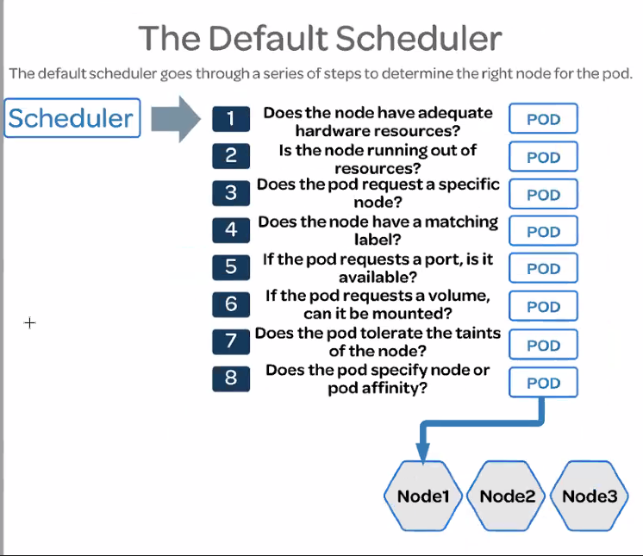

Placement based on node name , if not there it will be in pending status

132 kubectl get nodes
133 kubectl get pods
134 kubectl create -f https://raw.githubusercontent.com/lerndevops/educka/master/pods/placement/nodeName.yml
135 kubectl get pods -o wide
136 kubectl describe pod kubeserve-cf9d7797c-2sgb2
137 kubectl delete deploy kubeserve

Scheduling based on labels
269 kubectl label node node2 color=green
270 kubectl label node node1 owner=sainath
271 kubectl descibe node nod1
272 kubectl descibe node node1
273 kubectl describe node node1
274 kubectl get nodes --show-labels
275 kubectl get pods
276 vi selector.yml
277 kubectl create -f selector.yml

Node affinity – multiple options with weightage with match expressions – not generally used as it is more advanced , node selector with single label is fine in general scenarios

Sometimes we need to write the rules at the node level

kubectl delete all --all

kubectl get nodes

156 kubectl run pod1 --image nginx
157 kubectl run pod2 --image nginx
158 kubectl get pods -o wide
159 kubectl taint node node2 zone=red:NoSchedule
160 kubectl get pods -o wide
161 kubectl describe node node2
162 clear
163 kubectl run pod3 --image nginx
164 kubectl run pod4 --image nginx
165 kubectl run pod5 --image nginx
166 kubectl get pods -o wide
167 vi t.yml

169 kubectl create -f t.yml
170 kubectl get pods -o wide

apiVersion: apps/v1
kind: Deployment
metadata:
name: kubeserve1
spec:
replicas: 5
selector:
matchLabels:
app: kubeserve
template:
metadata:
name: kubeserve
labels:
app: kubeserve
spec:
tolerations:
- key: zone
operator: "Equal"
value: "red"
effect: "NoSchedule"
containers:
- image: leaddevops/kubeserve:v1
name: app

Taint and Toleranance in Kubernetes

Taint - is restriction at the node level (will not effect existing pods)
Tolerance – extra permission at the pod level is tolerance

Untaint
kubectl taint node node2 zone=red:NoSchedule-

One more taint NoExecute (apart from NoSchedule)
Existing pods are terminated when NoExecute

Untaint
kubectl taint node node2 type=app:NoExecute-

Bydefault master have a taint , that’s why pods are not deployed
Tolerance overrides taint

How to send node to a maintenance mode
Drain – removes existing nodes and make this node unshedulable
Cordon – existing nodes remains and make this node unshedulable

Uncordon – will remove the drain or cordon on the node

Namespace limits –
Objects limits / Resources limits

https://raw.githubusercontent.com/lerndevops/educka/master/security/namespaces/resource-quotas/object-counts-demo.yml

kubectl create deploy deploy1 --image nginx -n prod
kubectl run pod1 --image nginx -n prod

kubectl get quota object-counts -n prod
kubectl describe quota object-counts -n prod

etcd backup/restore – key value database
etcdtl is the command prompt to interact with etcd

mkdir /etcd-backup

ETCDCTL_API=3 etcdctl --endpoints=10.128.0.3:2379 --cacert /etc/kubernetes/pki/etcd/ca.crt --cert /etc/kubernetes/pki/etcd/server.crt --key /etc/kubernetes/pki/etcd/server.key snapshot save /etcd-backup/etcd-snapshot-latest.db

Take backup of etcd

Restore

ETCDCTL_API=3 etcdctl snapshot restore /etcd-backup/etcd-snapshot-latest.db --initial-cluster etcd-restore=https:// 10.128.0.3:2380 --initial-advertise-peer-urls=https:// 10.128.0.3:2380 --name etcd-restore --data-dir /var/lib/etcd

It takes the backup of the current state of the nodes

231 cd educka/monitoring/metrics-server/
232 ls -l
233 kubectl create -f .

Dashboard for Kubernetes management
Kubectl create -f https://raw.githubusercontent.com/lerndevops/educka/master/dashboard/dashboard-insecure.yml

Storage techniques

Google Kubernetes Engine

EmptyDir – to share the data across the container of a single pod – we can map to multi containers

kubectl delete all --all

6 vi pod.yml
7 kubectl create -f pod.yml
8 kubectl get pods

20 kubectl exec -it store -c cont1 -- bash
21 kubectl exec -it store -c cont2 -- bash
22 clear
23 history

apiVersion: v1
kind: Pod
metadata:
name: store
spec:
volumes:
- name: shared-vol
emptyDir: {}
containers:
- image: centos
name: cont1
command: ['sh', '-c', 'sleep 3600']
volumeMounts:
- mountPath: /test1
name: shared-vol
- image: ubuntu
name: cont2
command: ['sh', '-c', 'sleep 3600']
volumeMounts:
- mountPath: /test2
name: shared-vol

INIT -- Containers

Preparatory containers
We can have multiple init containers

https://raw.githubusercontent.com/lerndevops/educka/master/pods/init-cont-pod-ex1.yml

watch kubectl get pods

ctrl+c

kubectl get pods -o wide

curl podIP

HostPath – data in the host

volumeMounts : inside of the container
volumes : outside the container
good for only one node
not good for when running multiple nodes

Persistent Volume (PV)

https://raw.githubusercontent.com/lerndevops/educka/master/storage/pv.yml (available)

PVC
https://raw.githubusercontent.com/lerndevops/educka/master/storage/pvc.yml (booking)

https://raw.githubusercontent.com/lerndevops/educka/master/storage/pvc-hostpath-pod.yml (associated with PVC)

Pod is associated with PVC then only the path is allocated

Next is NFS

ConfigMap /Secret to inject data

ConfigMap – plain text
Secret – encodes the data
ConfigMap/Secret Volumes,ENV

ConfigMap

https://raw.githubusercontent.com/lerndevops/educka/master/storage/configmap-ex1.yml

Secret
https://raw.githubusercontent.com/lerndevops/educka/master/storage/secrets-ex1.yml

https://github.com/lerndevops/microservices-demo
https://github.com/lerndevops/microservices-demo/blob/master/deploy/kubernetes/complete-demo.yaml

Kubernetes Security
Kubernetes itself acts as an certification authority
Everytime we run kubectl , it will look for the config file where the api server information is there

9 kubectl get nodes -o wide
10 cd /etc/kubernetes/pki/
11 ls -l
12 clear
13 cd
14 clear
15 kubectl get nodes
16 id
17 cd /root/.kube/
18 ls -l
19 vi config
20 kubectl get nodes
21 rm config
22 ls -l
23 kubectl get nodes
24 kubectl --kubeconfig=/etc/kubernetes/admin.conf get nodes
25 cp /etc/kubernetes/admin.conf /root/.kube/config
26 kubectl get nodes
27 clear

Create users and appl config

9 kubectl get nodes -o wide
10 cd /etc/kubernetes/pki/
11 ls -l
12 clear
13 cd
14 clear
15 kubectl get nodes
16 id
17 cd /root/.kube/
18 ls -l
19 vi config
20 kubectl get nodes
21 rm config
22 ls -l
23 kubectl get nodes
24 kubectl --kubeconfig=/etc/kubernetes/admin.conf get nodes
25 cp /etc/kubernetes/admin.conf /root/.kube/config
26 kubectl get nodes
27 clear

31 mkdir /home/certs
32 ls -l
33 cd /home/certs/
34 ls -l
35 openssl genrsa -out user1.key 2048
36 ls -l
37 cat user1.key
38 openssl genrsa -out user2.key 2048
39 openssl genrsa -out user3.key 2048
40 ls -l
41 clear
42 ls -l
43 openssl req -new -key user1.key -out user1.csr -subj "/CN=user1/O=devops"
44 ls -l
45 cat user1.csr
46 openssl req -new -key user2.key -out user2.csr -subj "/CN=user2/O=devops"
47 openssl req -new -key user3.key -out user3.csr -subj "/CN=user3/O=devops"
48 ls -l
49 clear
50 ls -l /etc/kubernetes/pki/
51 openssl x509 -req -in user1.csr -CA /etc/kubernetes/pki/ca.crt -CAkey /etc/kubernetes/pki/ca.key -CAcreateserial -out user1.crt -days 1000
52 openssl x509 -req -in user2.csr -CA /etc/kubernetes/pki/ca.crt -CAkey /etc/kubernetes/pki/ca.key -CAcreateserial -out user2.crt -days 1000
53 openssl x509 -req -in user3.csr -CA /etc/kubernetes/pki/ca.crt -CAkey /etc/kubernetes/pki/ca.key -CAcreateserial -out user3.crt -days 1000
54 ls -l
55 cp /etc/kubernetes/admin.conf users.conf
56 vi users.conf
57 cat user1.crt
58 cat user1.crt | base64
59 cat user1.key | base64
60 vi users.conf
61 clear
62 kubectl --kubeconfig=users.conf config view
63 vi users.conf
64 kubectl --kubeconfig=users.conf config view
65 kubectl --kubeconfig=users.conf version --short
66 kubectl --kubeconfig=users.conf get pods
67 kubectl --kubeconfig=users.conf config get-contexts
68 kubectl --kubeconfig=users.conf config use-context user2@kubernetes
69 kubectl --kubeconfig=users.conf config get-contexts
70 kubectl --kubeconfig=users.conf version --short
71 kubectl --kubeconfig=users.conf get pods
72 kubectl --kubeconfig=users.conf config get-contexts
73 kubectl --kubeconfig=users.conf config use-context user3@kubernetes
74 kubectl --kubeconfig=users.conf config get-contexts
75 kubectl --kubeconfig=users.conf version --short
76 kubectl --kubeconfig=users.conf get pods

root@master:/home/certs# cat users.conf
apiVersion: v1
clusters:
- cluster:
certificate-authority: /etc/kubernetes/pki/ca.crt
server: https://10.128.0.8:6443
name: kubernetes
contexts:
- context:
cluster: kubernetes
user: user1
name: user1@kubernetes
- context:
cluster: kubernetes
user: user2
name: user2@kubernetes
- context:
cluster: kubernetes
user: user3
name: user3@kubernetes
current-context: user3@kubernetes
kind: Config
preferences: {}
users:
- name: user1
user:
client-certificate: /home/certs/user1.crt
client-key: /home/certs/user1.key
- name: user2
user:
client-certificate: /home/certs/user2.crt
client-key: /home/certs/user2.key
- name: user3
user:
client-certificate: /home/certs/user3.crt
client-key: /home/certs/user3.key

Authorization

Roles – What a user can do at namespace level
RoleBindings
Clusterroles – what a user can do at cluster level
Clusterrolebindings

Kubectl api-resources few are namespace mapped and others are not

9 kubectl get nodes -o wide
10 cd /etc/kubernetes/pki/
11 ls -l
12 clear
13 cd
14 clear
15 kubectl get nodes
16 id
17 cd /root/.kube/
18 ls -l
19 vi config
20 kubectl get nodes
21 rm config
22 ls -l
23 kubectl get nodes
24 kubectl --kubeconfig=/etc/kubernetes/admin.conf get nodes
25 cp /etc/kubernetes/admin.conf /root/.kube/config
26 kubectl get nodes
27 clear

31 mkdir /home/certs
32 ls -l
33 cd /home/certs/
34 ls -l
35 openssl genrsa -out user1.key 2048
36 ls -l
37 cat user1.key
38 openssl genrsa -out user2.key 2048
39 openssl genrsa -out user3.key 2048
40 ls -l
41 clear
42 ls -l
43 openssl req -new -key user1.key -out user1.csr -subj "/CN=user1/O=devops"
44 ls -l
45 cat user1.csr
46 openssl req -new -key user2.key -out user2.csr -subj "/CN=user2/O=devops"
47 openssl req -new -key user3.key -out user3.csr -subj "/CN=user3/O=devops"
48 ls -l
49 clear
50 ls -l /etc/kubernetes/pki/
51 openssl x509 -req -in user1.csr -CA /etc/kubernetes/pki/ca.crt -CAkey /etc/kubernetes/pki/ca.key -CAcreateserial -out user1.crt -days 1000
52 openssl x509 -req -in user2.csr -CA /etc/kubernetes/pki/ca.crt -CAkey /etc/kubernetes/pki/ca.key -CAcreateserial -out user2.crt -days 1000
53 openssl x509 -req -in user3.csr -CA /etc/kubernetes/pki/ca.crt -CAkey /etc/kubernetes/pki/ca.key -CAcreateserial -out user3.crt -days 1000
54 ls -l
55 cp /etc/kubernetes/admin.conf users.conf
56 vi users.conf
57 cat user1.crt
58 cat user1.crt | base64
59 cat user1.key | base64
60 vi users.conf
61 clear
62 kubectl --kubeconfig=users.conf config view
63 vi users.conf
64 kubectl --kubeconfig=users.conf config view
65 kubectl --kubeconfig=users.conf version --short
66 kubectl --kubeconfig=users.conf get pods
67 kubectl --kubeconfig=users.conf config get-contexts
68 kubectl --kubeconfig=users.conf config use-context user2@kubernetes
69 kubectl --kubeconfig=users.conf config get-contexts
70 kubectl --kubeconfig=users.conf version --short
71 kubectl --kubeconfig=users.conf get pods
72 kubectl --kubeconfig=users.conf config get-contexts
73 kubectl --kubeconfig=users.conf config use-context user3@kubernetes
74 kubectl --kubeconfig=users.conf config get-contexts
75 kubectl --kubeconfig=users.conf version --short
76 kubectl --kubeconfig=users.conf get pods

root@master:/home/certs# cat users.conf
apiVersion: v1
clusters:
- cluster:
certificate-authority: /etc/kubernetes/pki/ca.crt
server: https://10.128.0.8:6443
name: kubernetes
contexts:
- context:
cluster: kubernetes
user: user1
name: user1@kubernetes
- context:
cluster: kubernetes
user: user2
name: user2@kubernetes
- context:
cluster: kubernetes
user: user3
name: user3@kubernetes
current-context: user3@kubernetes
kind: Config
preferences: {}
users:
- name: user1
user:
client-certificate: /home/certs/user1.crt
client-key: /home/certs/user1.key
- name: user2
user:
client-certificate: /home/certs/user2.crt
client-key: /home/certs/user2.key
- name: user3
user:
client-certificate: /home/certs/user3.crt
client-key: /home/certs/user3.key

82 kubectl api-resources
83 clear
84 kubectl api-resources | grep true
85 kubectl api-resources | grep flase
86 kubectl api-resources | grep false
87 clear
88 kubectl create ns dev
89 kubectl get ns
90 kubectl create role read-only-role --verb=get,list,watch --resource=pods,services --namespace=dev
91 kubectl get roles
92 kubectl get roles -n dev
93* kubectl describe role dev-admin-role -n dev
94 kubectl create rolebinding read-only-role-binding --role=read-only-role --user=user1 --namespace=dev
95 kubectl --kubeconfig=users.conf config get-contexts
96 kubectl --kubeconfig=users.conf config use-context user1@kubernetes
97 kubectl --kubeconfig=users.conf config get-contexts
98 kubectl --kubeconfig=users.conf get pods
99 kubectl --kubeconfig=users.conf get pods -n dev
100 kubectl run pod1 --image=nginx -n dev
101 kubectl --kubeconfig=users.conf get pods -n dev
102 kubectl --kubeconfig=users.conf run pod2 --image=nginx -n dev
103 kubectl --kubeconfig=users.conf get services -n dev
104 kubectl --kubeconfig=users.conf get services
105 kubectl --kubeconfig=users.conf get services -n kube-system
106 kubectl create role devns-admin-role --verb="*" --resource="*.*" --namespace=dev
107 kubectl create rolebinding devns-admin-role-binding --role=devns-admin-role --user=user2 --namespace=dev
108 kubectl describe rolebinding devns-admin-role-binding
109 kubectl describe rolebinding devns-admin-role-binding -n dev
110 kubectl --kubeconfig=users.conf config get-contexts
111 kubectl --kubeconfig=users.conf config use-context user2@kubernetes
112 kubectl --kubeconfig=users.conf get pods
113 kubectl --kubeconfig=users.conf get pods -n dev
114 kubectl --kubeconfig=users.conf delete pod pod1 -n dev
115 kubectl --kubeconfig=users.conf run pod1 --image=tomcat -n dev
116 kubectl --kubeconfig=users.conf get pods -n dev
117 kubectl --kubeconfig=users.conf create deploy dep1 --image=httpd -n dev
118 kubectl --kubeconfig=users.conf create deploy dep1 --image=httpd -n kube-system
119 kubectl --kubeconfig=users.conf get ns -n dev
120 kubectl --kubeconfig=users.conf get nodes -n dev

Kubectl create clusterrole read-only-cr –verb=get,watch,list –resource=pods,deployment,services,nodes,namespaces
Kubectl create clusterrolehinding read-only-cr-binding –clusterrole=read-only-cr –user=user3

User key bound to cluster role
We can provide permission at the group level

on master node

134 kubectl get nodes
135 kubectl config get-contexts
136 kubectl config view
137 clear
138 kubectl create clusterrole read-only-cr --verb=get,watch,list --resource=pods,deployment,services,nodes,namespaces
139 kubectl create clusterrolebinding read-only-cr-binding --clusterrole=read-only-cr --user=user3
140 history
141 clear
142 kubectl get clusterroles
143 kubectl describe clusterrole view
144 kubectl describe clusterrole admin
145 kubectl describe clusterrole cluster-admin
146 history
147 kubectl create clusterrolebinding cluster-admin-binding --clusterrole=cluster-admin --group=devops

on client server

27 kubectl config get-contexts
28 kubectl config use-context user1@kubernetes
29 kubectl config get-contexts
30 kubectl get pods -n dev
31 kubectl run pod3 --image=tomcat -n dev
32 cd .kube/
33 more config
34 clear
35 cd
36 kubectl config get-contexts
37 kubectl config use-context user3@kubernetes
38 kubectl get pods
39 kubectl get pods --all-namespaces
40 kubectl get ns
41 kubectl get nodes
42 kubectl get pv
43 kubectl get ds
44 kubectl get ds -n kube-system
45 clear
46 kubectl get ds -n kube-system
47 kubectl create ns prod
48 kubectl config get-contexts
49 kubectl config use-context user1@kubernetes
50 kubectl get ds -n kube-system
51 kubectl create deploy dep1 --image=nginx
52 kubectl create deploy dep1 --image=nginx - dev
53 kubectl create deploy dep1 --image=nginx -n dev
54 kubectl create deploy dep1 --image=nginx -n prod
55 kubectl create deploy dep1 --image=nginx -n kube-system

We will install kubectl client in our machine and will make the necessary config and interact with the nodes and pods etc…

Configure service accounts for Pods

Service accounts make the application do the necessary interactions with the API server
Service account can be mapped to cluster role similar to a group

152 kubectl create -f https://raw.githubusercontent.com/lerndevops/educka/master/dashboard/dashboard-insecure.yml
153 kubectl get pods
154 kubectl get services
155 kubectl get pods -n kube-system
156 clear
157 kubectl get serviceaccout
158 kubectl get serviceaccount
159 kubectl describe sa kubernetes-dashboard
160 kubectl describe sec kubernetes-dashboard-token-z5vjc
161 kubectl describe secret kubernetes-dashboard-token-z5vjc
162 kubectl create sa testuser
163 kubectl get saa
164 kubectl get sa
165 kubectl describe sa testuser
166 kubectl describe secret testuser-token-fvpjl
167 kubectl get clusterroles
168 kubectl get clusterrolebinding
169 kubectl delete clusterrolebinding kubernetes-dashboard
170 kubectl create clusterrolebinding dashboard-readonly-binding --clusterrole=read-only-cr --serviceaccount=default:kubernetes-dashboard
171 clear
172 kubectl get sa -n kube-system

Kind : ResourceQuota it can be applied on Namespace
When you create pod on namespace , then you need to specify the limits , since name space is associated with some limits

Resource limits can be applied at the resources level also , like pods , services ,deployment

190 vi resource-quota.yml
191 kubectl apply -f resource-quota.yml
192 vi resource-quota.yml
193 kubectl apply -f resource-quota.yml
194 kubectl get resourcequota
195 kubectl get resourcequota -n dev
196 kubectl run podx --image=nginx -n dev
197 kubectl run podx --image=nginx --requests "cpu=0.1,memory=100" --limits "cpu=0.2m,memory=200" -n dev
198 kubectl run podx --image=nginx --requests "cpu=0.1m,memory=100" --limits "cpu=0.2m,memory=200" -n dev
199 cp resource-quota.yml obeject-count.yml
200 vi obeject-count.yml
201 clear
202 kubectl create -f obeject-count.yml
203 kubectl get resourcequota
204 kubectl get resourcequota -n dev
205 kubectl get resourcequota -n qa
206 kubectl create deployment dep1 --image=httpd
207 kubectl create deployment dep1 --image=httpd -n qa
208 kubectl get deployment -n qa
209 kubectl create deployment dep2 --image=httpd -n qa
210 kubectl get deployment -n qa
211 kubectl get pods -n qa
212 kubectl get resourcequota -n qa
213 kubectl delete deploy dep2 on qa
214 kubectl delete deploy dep2 -n qa
215 vi obeject-count.yml
216 kubectl apply -f obeject-count.yml
217 clear
218 kubectl get resourcequota -n qa
219 clear
220 kubectl get resourcequota -n qa
221 kubectl create deployment dep2 --image=httpd -n qa
222 kubectl scale deployment dep1 --replicas 6 -n qa
223 kubectl get resourcequota -n qa
224 kubectl get deploy -n qa
225 kubectl get pods -n qa
226 kubectl get rs -n qa
227 kubectl describe rs dep1-849f46f8bd -n qa

root@master:~# cat resource-quota.yml
kind: Namespace
apiVersion: v1
metadata:
name: dev

---
kind: ResourceQuota
apiVersion: v1
metadata:
name: compute-resources
namespace: dev
spec:
hard:
requests.cpu: "1"
requests.memory: 1Gi
limits.cpu: "2"
limits.memory: 2Gi
root@master:~# cat obeject-count.yml
kind: Namespace
apiVersion: v1
metadata:
name: qa

---
kind: ResourceQuota
apiVersion: v1
metadata:
name: object-quota
namespace: qa
spec:
hard:
pods: "4"
services: "2"
count/deployments.apps: "1"

Networking

Networking in Docker

19 docker network ls
22 docker network inspect bridge
23 clear
33 docker run -d --name cont1 lerndevops/alpine:sleep
34 docker run -d --name cont2 lerndevops/alpine:sleep
35 docker ps
36 docker exec cont1 hostname -i
37 docker exec cont2 hostname -i
38 docker exec cont2 ping 172.17.0.2
39 docker exec cont1 ping 172.17.0.3
40 clear
41 docker network ls
42 docker network create --help
43 docker network create --driver bridge mynet --subnet 192.168.0.0/16 --gateway 192.168.0.1
44 docker network ls
45 docker network inspect mynet
46 docker run -d --name cont3 --network mynet lerndevops/alpine:sleep
47 docker run -d --name cont4 --network mynet lerndevops/alpine:sleep
48 docker ps
49 docker exec cont1 hostname -i
50 docker exec cont2 hostname -i
51 docker exec cont3 hostname -i
52 docker exec cont4 hostname -i
53 docker exec cont4 ping 192.168.0.2
54 docker exec cont4 ping 172.17.0.2
55 clear
56 docker ps
57 docker exec cont1 ifconfig
58 docker network connect mynet cont1
59 docker exec cont1 ifconfig
60 docker exec cont1 ping 192.168.0.2
61 docker exec cont1 ping 192.168.0.3
62 clear
63 docker ps
64 docker network disconnect mynet cont1
65 docker rm -f cont1 cont2 cont3 cont4
66 docker ps
67 docker run -d --network mynet --name cont1 lerndevops/alpine:sleep
68 docker exec cont1 ifconfig
69 docker network -d --name cont2 --network container:cont1 lerndevops/alpine:sleep
70 docker run -d --name cont2 --network container:cont1 lerndevops/alpine:sleep
71 docker ps
72 docker exec cont1 hostname -i
73 docker exec cont2 hostname -i
74 clear
75 docker run -d --name pause k8s.gcr.io/pause:3.2
76 docker ps
77 docker exec pause hostname -i
78 docker inspect ddad126aa3f3
79 docker run -d --network container:pause nginx
80 docker ps
81 docker exec 562b7e2125d3 hostname -i

Kubernetes does not uses docker container networking
It uses separate networking driver like weave
Virtual weave subnet 10.32.0.0/32

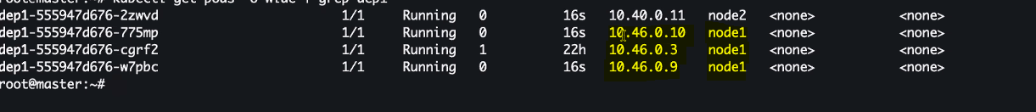

Subnet with in a each node

IP to name resolution
It is mentioned in /etc/hosts

/etc/resolv.conf
It contains the information of the DNS
Kubectl get pds -n kube-system -- contains two domain name servers

Kube-dns – domain name server
Every service in a namespace has a unique FQDN – fully qualified domain name

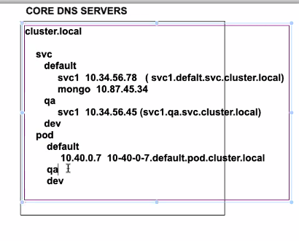
Service DNS & POD DNS validations

258 kubectl get pods -n kube-system
259 clear
260 kubectl get pods -n kube-system
261 kubectl get svc
262 curl 10.107.70.11
263 clear
264 kubectl get svc
265 kubectl delete deploy --all
266 kubectl delete svc --all
267 clearcucu
268 kubectl create deploy dep1 --image=nginx
269 kubectl scale deploy dep1 --replicas 4
270 kubectl get pods -o wide
271 kubectl expose deploy dep1 --name svc1 --type ClusterIP --port 80 --target-port 80
272 kubectl get pods
273 kubectl get svc
274 kubectl run dnstest --image=lerndevops/netshoot -- sleep 3600
275 kubectl get pods
276 kubectl get pods -o wide
277 kubectl get svc
278 kubectl exec -it dnstest -- bash
279 kubectl get svc -n kube-system
280 kubectl describe svc kube-dns -n kube-system
281 kubectl get pods -o wide -n kube-system
282 kubectl get svc -n qa
283 kubectl get deploy -n qa
284 kubectl expose deploy dep1 --name svc1 --type NodePort --port 80 --target-port 80 -n qa
285 clear
286 kubectl get services -n default
287 kubectl get services -n qa
288 kubectl exec -it dnstest -- bash
289 kubectl get pods -o wide
290 kubectl exec -it dnstest -- bash

under dnstest pod

bash-5.0# history
1 curl 10.98.129.169
2 curl svc1
3 nslookup 10.46.0.9
4 nslookup 10.98.129.169
5 cat /etc/hosts
6 cat /etc/resolv.conf
7 nslookup 10.98.129.169
8 nslookup 10.103.82.26
9 curl svc1
10 curl svc1.qa.svc.cluster.local
11 curl svc1.default.svc.cluster.local
12 clear
13 nslookup 10.46.0.5
14 nslookup 10-46-0-5.default.pod.cluster.local
15 cat /etc/resolv.conf
16 history

INGRESS

Incoming traffic to your application

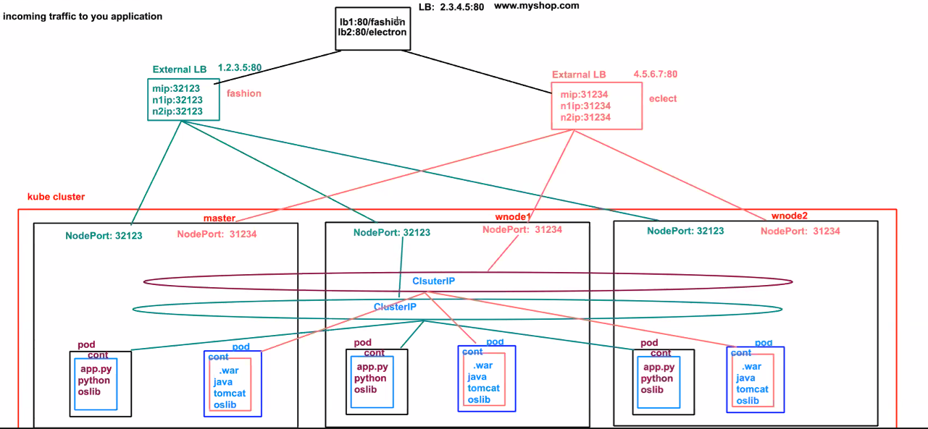

Above is without ingress

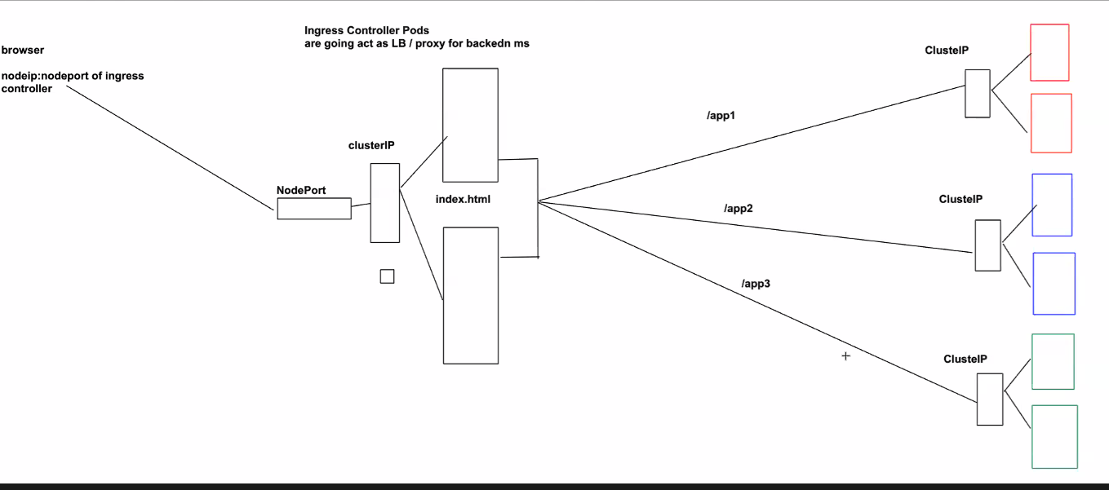

Ingress Resource – set of rules to forward the request into backend cluster ip services

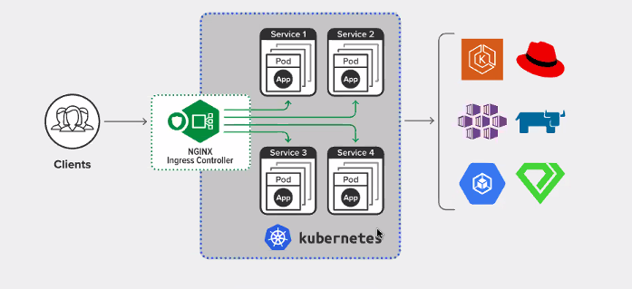

293 kubectl delete deploy --all
294 kubectl delete svc --all
295 kubectl apply -f https://raw.githubusercontent.com/lerndevops/educka/master/ingress/deploy-app.yml
296 kubectl get deployments
297 kubectl get pods -o wide
298 kubectl get svc
299 kubectl describe svc app1-svc
300 clear
301 kubectl apply -f https://raw.githubusercontent.com/lerndevops/educka/master/ingress/nginx-ing-controller.yaml
302 kubectl get pods
303 clear
304 kubectl get all -n ingress-nginx
305 kubectl apply -f https://raw.githubusercontent.com/lerndevops/educka/master/ingress/service-nodeport.yaml
306 kubectl get all -n ingress-nginx
307 kubectl apply -f https://raw.githubusercontent.com/lerndevops/educka/master/ingress/ingress-rule.yml
308 kubectl get ingress
309 kubectl describe ingress mying-rule

Stateful services – all the database services – data being used across sessions
In general StatefulSet Controller == deploying DB Services/Messaging services
For DB serives , we start in a sequential manner , not parallel

Headless service doesn’t have cluster IP , cluster IP is mentioned as none

341 kubectl apply -f https://raw.githubusercontent.com/lerndevops/educka/master/controllers/statefulsets/statefulset-ex1.yml
342 clear
343 kubectl scale sts db --replicas 12
344 kubectl scale sts db --replicas 8
345 kubectl delete pod db-4
346 kubectl get services
347 kubectl exec -it dnstest -- bash

watch kubectl get pods

Metrics

There are some internal tools , metrics app in kube-system , which provide few of the data
Premetheus -- available for metrics collection – it also provides the UI for getting the data
It stores data locally

In real time we may need to store the data externally

350 git clone https://github.com/lerndevops/educka
351 cd educka/monitoring/metrics-server/
352 kubectl apply -f .
363 ls -l
364 cd educka/monitoring/kube-state-metrics/standard/
365 ls -l
366 kubectl apply -f .
367 kubectl get pods -n kube-system
368 cd ..
369 clear
370 ls -l
371 cd prometheus/
372 ls -l
373 vi prometheus.yaml
374 kubectl apply -f prometheus.yaml
375 kubectl get all -n monitoring
376 kubectl describe pod/prometheus-deployment-58f6fb464b-clwwz -n monitoring
377 clear
378 ls -l
379 vi grafana.yml
380 kubectl apply -f grafana.yml
381 kubectl get all -n monitoring

Grafana
We can import , the dashboard
https://grafana.com/grafana/dashboards/6417

Autoscaling

Kind : HorizontalPodAutoscaler

watch kubectl top pods
watch kubectl get hpa

393 kubectl apply -f https://raw.githubusercontent.com/lerndevops/educka/master/controllers/hpa/hpa.yml
394 clear
395 kubectl get deployment
396 kubectl get service
397 kubectl get hpa
398 kubectl top pods
399 clear
400 kubectl get pods
401 apt-get install apache2-utils
402 cleary

403 ab
404 clear
405 kubectl get services
406 ab -n 100000 -c 1000 http://10.110.5.55:80/

AKS – managed Kubernetes cluster

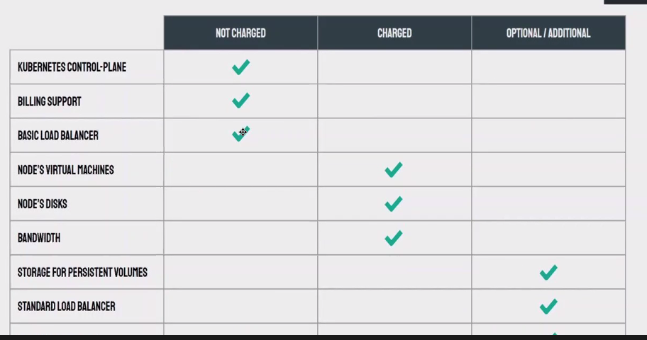

https://github.com/lerndevops/educka/tree/master/install
https://github.com/lerndevops/aks

